D6422-LA08-ONLINE QUIZ #4_Modulus

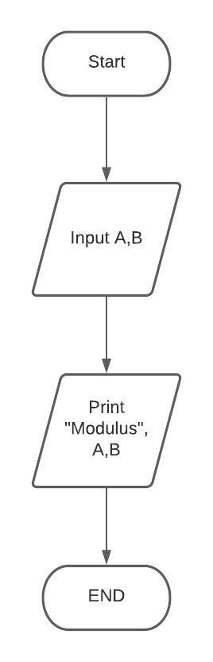

D6422-LA08-ONLINE QUIZ #4_Addition

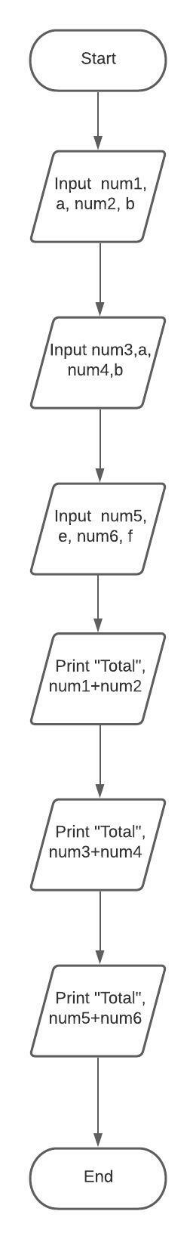

D6422-LA08-ASSIGNMENT #4_Arithmetic

